附件1：
学堂在线、雨课堂教发平台课程名录
学堂在线平台：https://synu.yuketang.cn/pro/educational/user
进入网址后点击“青蓝工程”选修课程，即可选择自身感兴趣的课程进行修读
（1）金课慕课教学版块
https://www.xuetangx.com/course/RCOE04011000178/4227149?channel=search_result
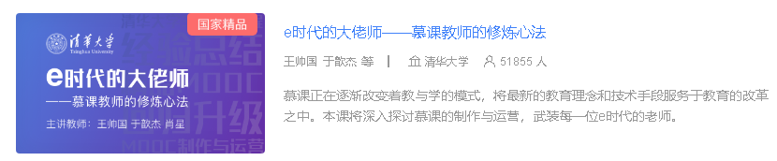
https://www.xuetangx.com/course/RCOE04011000249/4227145?channel=search_result

（2）论文学术版块：
https://www.xuetangx.com/course/THU04011000617/5881746?channel=search_result

https://www.xuetangx.com/course/synu12021001993/5883344?channel=search_result
https://www.xuetangx.com/course/THU12051000419/5882993?channel=search_result

（3）信息化教学:
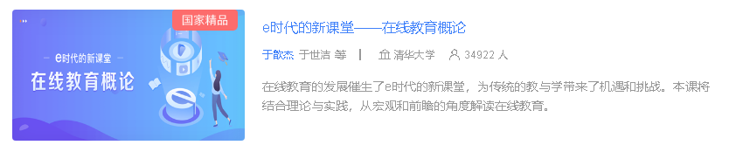
https://www.xuetangx.com/search?query=%E4%BA%8E%E6%AD%86%E6%9D%B0&org=&classify=&type=&status=&page=2

https://www.xuetangx.com/course/1232952fu051205/4049185?channel=search_result

